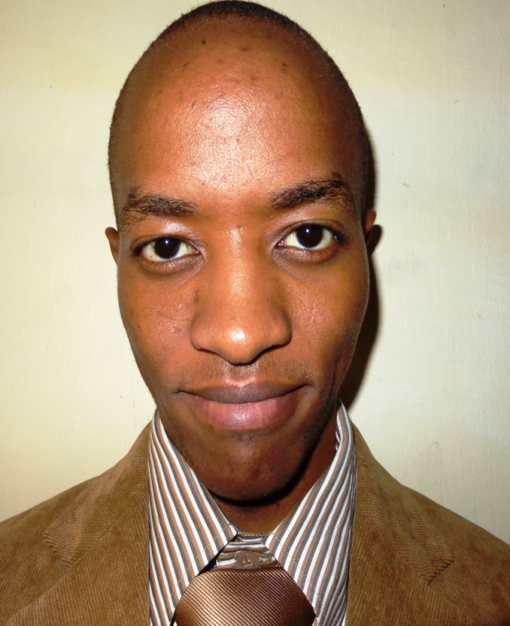
Profile

Name: Tom Jalio

Academic and Professional Qualification:
Master’s degree in Digital Journalism (pursuing) – Aga Khan University
Bachelor’s degree in Journalism and Media Studies – University of Nairobi
Member of the Kenya Editors Guild
Work Experience
Jalio has 12 years’ experience in magazine, e-book and newspaper industries

Currently the features editor of the Star newspaper

A member of both Queensway Sacco Limited and Queensway Housing Cooperative Society Limited

